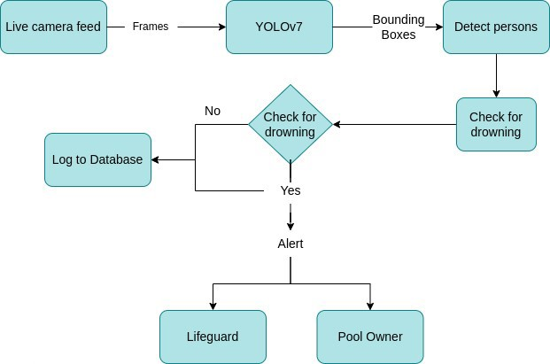**Project Design Phase-II Data Flow Diagram & User Stories**

|  |  |
| --- | --- |
| Date | 28 October 2022 |
| Team ID | PNT2022TMID51724 |
| Project Name | Virtual eye -life Gurd for Swimming Pools to Detect Active Drowning |
| Maximum Marks | 4 Marks |

**Data Flow Diagrams:**

A Data Flow Diagram (DFD) is a traditional visual representation of the information flows within a system. A neat and clear DFD can depict the right amount of the system requirement graphically. It shows how data enters and leaves the system, what changes the information, and where data is stored.

**User Stories**

|  |  |  |  |  |  |  |
| --- | --- | --- | --- | --- | --- | --- |
| **User Type** | **Functional**  **Requirement**  **(Epic)** | **User Story**  **Number** | **User Story / Task** | **Acceptance criteria** | **Priority** | **Release** |
| Customer (Pool owner) | Installation | USN-1 | As a pool owner, I can install the cameras and set up the drowning detection system | I can connect the cameras to the cloud-hosted software | High | Sprint-1 |
|  | Detecting the drowning persons | USN-2 | As a user, I can find the drowning persons by using the drowning detection system | I would receive an alert if a person is drowning | High | Sprint-1 |
|  | Notify the lifeguard | USN-3 | As a user, I can notify the lifeguard when the system detects a drowning person | I can set up an alarm that would notify the lifeguard | High | Sprint-2 |
| Customer (Lifeguard) | Rescue people | USN-4 | As a user, I can rescue the drowning persons from the pool | I can save the drowning person | High | Sprint-2 |
| Customer  (Swimmers) | Safety | USN-5 | As a user, I can swim without the fear of drowning | I can swim safely with the help of the system and the lifeguard | Medium | Sprint-2 |
| Customer Care Executive | Contact | USN-6 | resolve technical issues | I can contact the customer care executive to resolve  any issues | Medium | Sprint-3 |
| Administrator | Dashboard | USN-7 | Management of the drowning detection system and database management. | I can access the system’s logs and any other data instantly | High | Sprint-4 |